**Assignment -4**

Digital Marketing

|  |  |
| --- | --- |
| Student Name | Kali Sangareshwari M |
| Student Roll Number | 20URCS019 |
| NM ID | 2CACCF0CD5ECD7581324C8C06D826450 |
| College Name | AAA College of Engineering and Technology |

**QUESTION:**

**Create email newsletter design using MailChimp or Canva tool.**

**EMAIL NEWSLETTER USING CANVA:**

**Newsletter link:** <https://www.canva.com/design/DAFtYpy8gRA/H5sfJsaf153rmoYT10Ci8Q/edit?utm_content=DAFtYpy8gRA&utm_campaign=designshare&utm_medium=link2&utm_source=sharebutton>

**Newsletter Title: Royal Wrists**

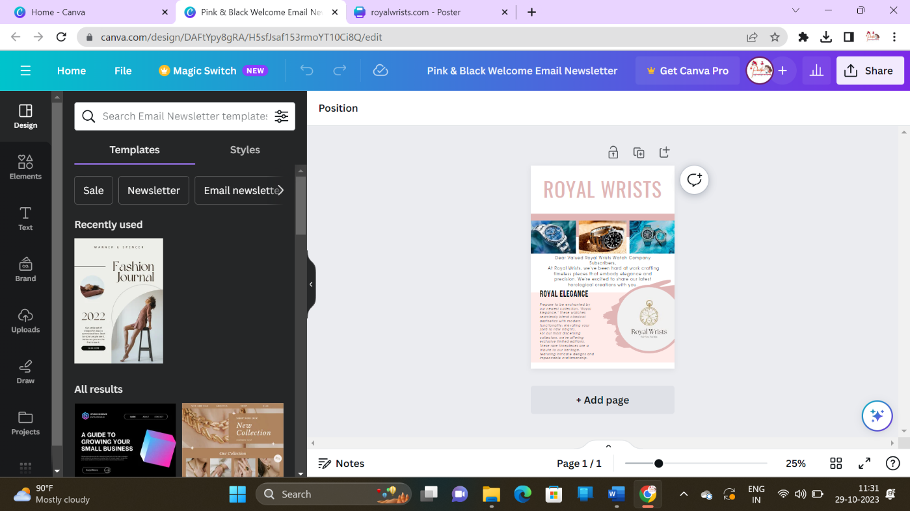

**EMAIL Newsletter:**

